Pain points

Pain points are problems that occur at the different levels of the customer experience. Interaction level . A pain point refers to a very specific problem that customers of your particular product or service are experiencing. You can think of pain points as problems – plain and simple! 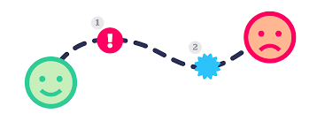

For example, if a customer is using an e-commerce platform, and if the checkout and payment process is rather lengthy, then they might just quit and jump to another e-commerce provider. This is a pain point, which if a product team is able to identify and correct, can boost their [conversions](https://seodigitalgroup.com/what-is-a-conversion/).

Pain points are persistent problems with a product or service that can inconvenience customers and their businesses. Or to simply put it, they’re unmet needs waiting to be satisfied. Any type of customer can have pain points, on an individual level or for companies on a large scale. Let’s look at some common examples.

We’ll break down more specific scenarios further into this article, but for starters, a typical pain point could be something like:

* A customer needs a service above their budget: Financial limitations stop customers from working efficiently and leads them to search for more cost-effective alternatives.
* A business with too many redundant steps in its strategy: Too much process lead time costs money and reveals a need to reduce it.
* Communication made unclear between departments: Teams need to find a way to communicate information more properly to reduce errors in process.

When is it best used?

Pain Points is a term used to characterize problems in existing products, services or other experiences. They are often identified and associated with undue effort, confusion or friction limiting a person's ability to accomplish something. It is therefore a term that is commonly used in presenting (delivering) [user research](https://www.curiositytank.com/ux-lexicon-blog/uxr/user-experience-research) results to illustrate users’ problems.

It is also sometimes used as a starting point for designers or researchers trying to understand a potential white space/need area that may be resolved by a new or different product, service, feature or communication. In this instance, pain points are used to inform assumptions or hypotheses that bring alive opportunities/challenges the team could solve for.

**Examples of pain points** 

**1. Interaction-level pain point: A user is passed from support person to support person.**

We’ve all been there — we call customer support, say what we need, only to be passed to another department who “will be able to handle that request.” Not only is time wasted, but we have to explain our issue over again. Even more, there are often discrepancies in the information we are told. This type of interaction causes wasted time and confusion.

**2. Journey-level pain point: A user places an order and does not receive it for months.**

I recently purchased a Peloton bike. After ordering it, I was alerted that the bike would be delivered 3 months from my order date. While this wait time was disappointing, it was somewhat expected given the high demand for the bikes during COVID-19. However, after the 3-month wait, I received a call that the bike would be delivered while I was scheduled to speak at a NN/g UX Conference. Upon calling customer support to reschedule, I was given the choice to take the assigned appointment or reschedule my delivery appointment to another 3 months from then. The pain point in this journey was the long duration between the beginning of the journey (the bike purchase) and the completion of the journey (taking my first ride on the bike). Additional point points included the lack of upfront communication about wait times, the need to call customer support to reschedule delivery, and the lack of flexibility in appointment times.

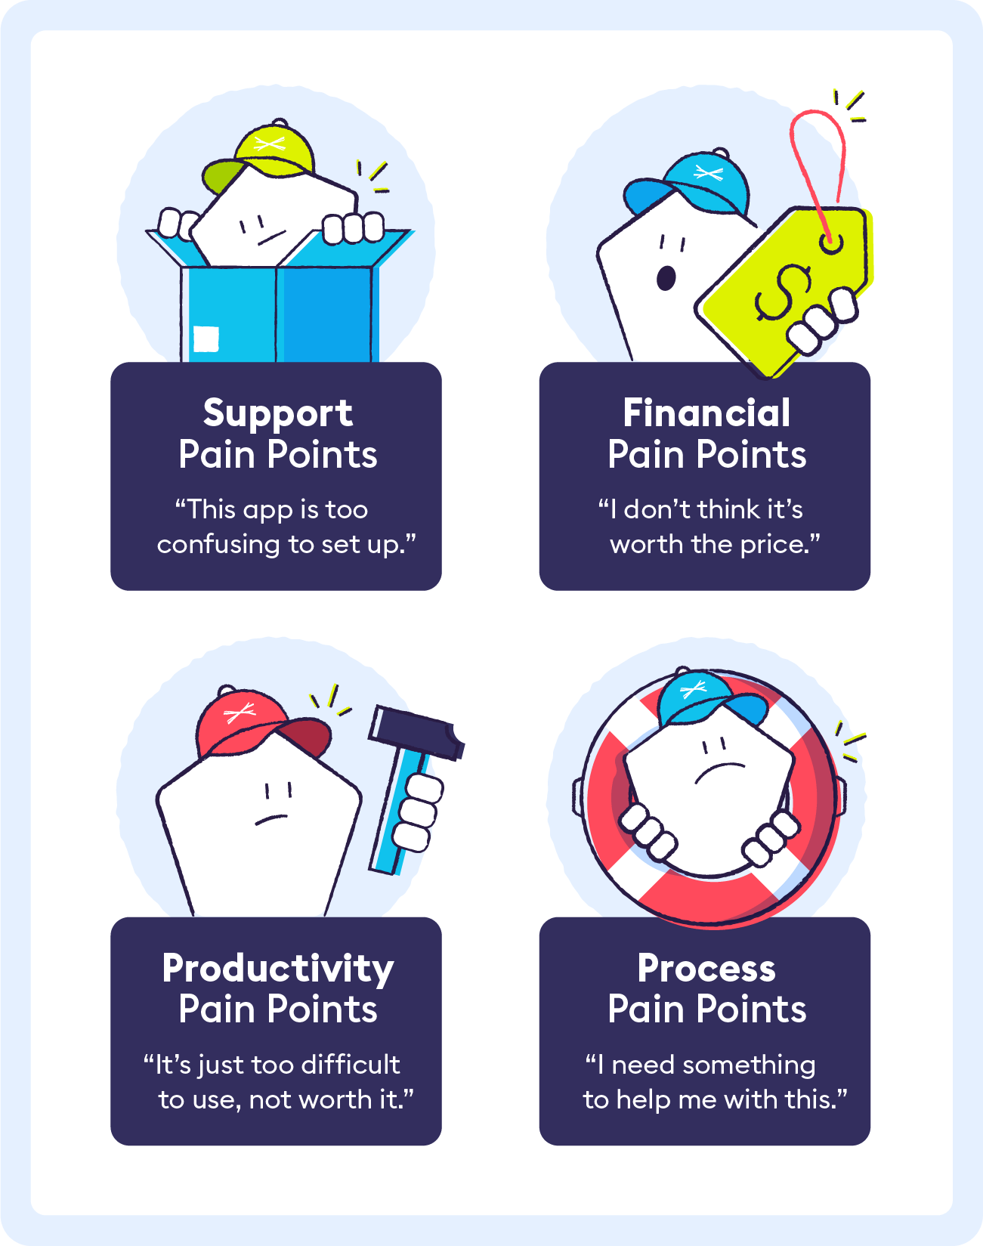

**3. Relationship-level pain point: A user pays for a service but still has to watch ads.**

I pay for a subscription to Hulu to stream TV shows. However, I still have to watch advertisements periodically. This is an anomaly compared to other streaming services (Netflix and HBO Max, for example) and does not meet my user expectations or industry norms. These advertisements are a pain point in my overall relationship with Hulu — my trust in the company is diminished due to the financial commitment I’ve made, without equal reward.  Not only that, but the ads have prompted me to waste time reading forums and contacting Hulu support to solve this problem with no success.